Dear Parents,
Welcome to third grade! Third grade is such an important transition. Your child will now be earning grades on completed work. It marks a time of even more responsibility and independence as well. I have compiled this small handbook to help you become familiar with guidelines and expectations of third grade. Please know that it is my desire to help your child in any way possible. Please do not hesitate to contact me throughout the coming school year if you have any questions or problems concerning your child. It is through working together that we can ensure a wonderful year for your child. I am looking forward to a great year of learning and fun!
Sincerely,
Tammy Harper
Teacher Contact Information
Tammy Harper
Email: tharper@tcss.net
Website: www.HarperGrade3.weebly.com
School Phone: 205-342-2664
Remind (Sign up information on next page)

Agendas/Homework Binder
It is very important that we work together to help students develop good organization and homework habits. To help us achieve this goal, your child will be given a homework binder and agenda. The agenda serves as a means of communication between school and home. The daily assignment boxes give your child the opportunity to develop the habit of recording homework assignments and reminders. Please make it a priority to check your child's homework binder and agenda every day. Parents are asked to initial the agenda as a means of verifying that homework has been completed and all school notes have been read. Please use it to express any questions or concerns that you might have. This binder will be used to send home all checked work (not counted as a grade in the gradebook) and written parent/school communication. Completed homework, letters, lunch money, book orders, etc. should be placed in the front pocket.

Weekly Graded Work Folder
On Mondays, a folder with the previous week’s graded work and a behavior report will be sent home for you to see, sign, and return. The graded work has been recorded in the gradebook and INOW and will be reflected on your child’s report card. I will return all graded work to you at the end of the semester.

Class Work
Students are expected to stay on-task and finish class work within a reasonable amount of time. Depending on the assignment, students who stay on-task, but do not finish, may be allowed to take some work home to finish. This opportunity will not be offered to students who choose not to use their class time wisely. Failure to complete or turn in class work may result in your child receiving a zero for that assignment.

Grading
The following grading scale will be used this year on class assignments, progress reports, and report cards:
A=90-100 B=80-89 C=70-79 D=60-69 F=Below 60

Progress Reports and Report Cards
The school year is divided into four nine week periods. A report card will be sent home at the end of each nine week grading period. To keep you updated on your child's progress, a progress report will be sent home at the midway point of each nine weeks.

Homework
Homework is an excellent way to practice and reinforce skills being taught throughout the school day. It is also a great way to work on the responsibility and study habits that will be so increasingly important as your child moves on to the upper grades. It is very important that your child complete any assigned homework each and every day. There are two pockets in your child's homework binder. Please remove daily any checked work from the Keep at Home pocket in the back and return papers, including homework, in the Return to School pocket. Weekly homework assignments will include the following:
-Your child will be expected to read each night for at least 20 minutes and to record what has been read in a reading log.
-Math practice to reinforce concepts being introduced in class may be assigned as needed. Your child will also need daily practice with basic facts in addition, subtraction, and multiplication.
Conferences
Communication between home and school is essential. I am always happy to discuss your child’s progress via notes, emails, phone, or conferences. Please prearrange dates and times for conferences. I am not available on Monday afternoons due to meetings.

Attendance
It is important for students to attend school every day. Even a few occasions of being tardy or checked out can greatly affect your child's learning. When students check-in late or check-out early, they are missing valuable instructional time. Students are not allowed to check-out after 2:30 p.m. Students who have missed work will have two days to make it up. In the event of an extended absence, it may be beneficial to pick up your child's missed work after 2:00 p.m. from the office so that your child will not fall behind. Please remember to send a written excuse within two days of your child's absence. If one is not received within that time, the absence is marked as unexcused. Any absence over ten days requires a doctor's excuse. It is very important to understand that your child may receive a zero for failing to complete any assigned make-up work or for any work assigned during an absence that is not excused according to Tuscaloosa County Board Policy.

Parties/Special Snacks
We will have a Halloween Special Snack, Christmas Party, and Valentine’s Day Special Snack. If you want to send birthday treats for the class, I ask that you prearrange with me. Time does not permit an actual birthday party, but students do enjoy a quick celebration during their usual snack time. Policy states that all food sent to students must be commercially prepared and sealed. We are unable to serve home baked goods.

Snack
Every effort will be made to provide your child the opportunity each day to eat a snack. We ask that you please encourage your child to eat healthy snacks. Children will not be permitted to drink carbonated beverages or eat sugary snacks at school. If your child brings a snack from home, please remember that glass containers should not be used.

Change of Transportation
If your child has a change in transportation, you must send a signed note or email the office. These notes must be approved by administration. Without a note, I will have to send your child home the way your child is normally transported.

3rd Grade Discipline Plan
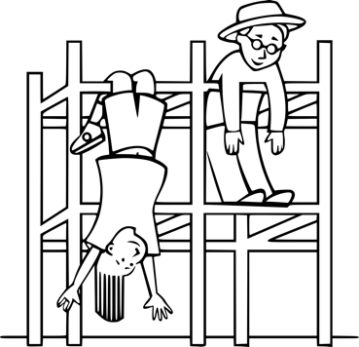
All students are expected to follow classroom and school rules. Our goal is to help students develop the ability to be respectful, responsible, and resourceful. Your child's behavior will be recorded daily in your child's agenda. A yellow or red ticket will be attached to the agenda page explaining the problem behavior in more detail to make you aware of any areas that need improvement. Students will be rewarded each week with free play for good behavior and be punished for misbehavior or incomplete classwork by missing free play.
When Discipline Intervention fails to promote progress or a severe disruption occurs, After School Detention or Suspension may be assigned. Parents play a vital role in encouraging appropriate behavior at school. Any reinforcement at home is greatly appreciated. Please make every effort to congratulate your child for a good day as well as to encourage your child to work on behaviors that may need improvement.

Medication Forms/Medical Alert Forms
Any medication that must be taken during the school day must be administered by our school nurse. She cannot administer medication without the proper completed forms. This applies to any over the counter and prescription medications including cough drops and sore throat lozenges. You may get these medication forms from the school office. Please remember that all medication must be sent in its original container. If your child has been diagnosed with any medical condition, a medical alert form must be on file with the school nurse.

Math
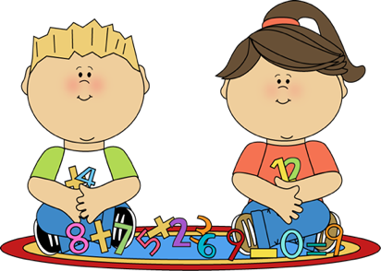
Each day your child will be asked to participate in a wide variety of mathematics activities. Your child will learn through hands-on activities, group discussions, and skills work. Third grade math skills include addition and subtraction with regrouping, multiplication, division, fractions, geometry and time. Homework may be given to provide additional practice and reinforcement of concepts being taught. Please assist your child with math homework by allowing your child to arrive at the answer, checking your child's work, but letting your child correct any problems missed. Daily practice of basic facts in addition, subtraction, and multiplication is very important. Grades in math will come from daily class work, quizzes, assessments, and participation.

Science/Social Studies
Students will be learning many concepts in Social Studies and Science. Your child’s grades will come from daily class work, participation, projects, and assessments. Graded work will be sent home often to keep you aware of your child’s progress.

Reading
Your child will be taught reading this year according to the Common Core State Standards for English Language Art for Reading and Language Arts. Students will be tested on each standard.
Our reading time will begin with a mini-lesson in whole group where I will give direct instruction on the standard. Students will work with a partner or in small group to practice and reinforce the skill. Finally, students will work independently using the new skill. A test will be given to ensure mastery.
Studies have indicated that there is a strong correlation between the amount of reading practice and comprehension development. To become a better reader, your child will need to spend time doing just that-reading! Every effort will be made to help students learn how to select "just right" books for reading. Students will be given opportunities to take AR tests on the reading being completed during the school day. It is also very important that your child complete reading practice each night for homework. Please review book choice (level) and sign your child's reading log each night to encourage this habit in your child.
Grades in reading will come from daily class work, quizzes, assessments, and participation.
Language Arts
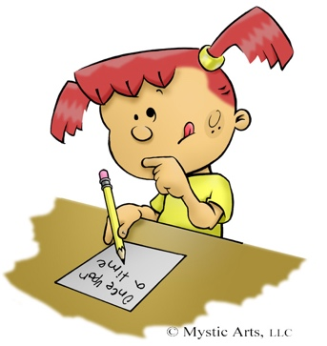
Each day your child will be participating in grammar, writing, or cursive handwriting activities. Our writing time will begin with the children coming together for a mini-lesson in which I give direct instruction in the skill. Additional instruction will be given during student-teacher conferences as well as in small groups. Writers will also be given time to work with a partner and share with the group.
Your child will be receiving further review and reinforcement in the correct formation of cursive letters. Our goal is to establish a habit of neat and legible handwriting. We want to be able to read all the wonderful ideas and stories your child has to share!
Grades in Language Arts will come from daily class work, quizzes, assessments, and participation in writing, grammar, and handwriting.

Please sign below that you have read and understand the 3rd Grade Handbook. Please return this signed page only to school.

Child’s Name: _______________________________

Parent Signature

X____________________________________________

